“CGI Friday Ep1”
By
Chroma Crew Studios
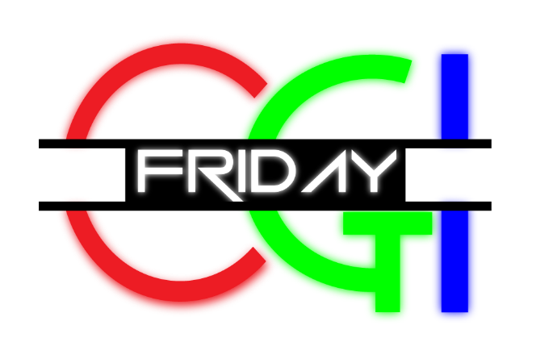
Wiltshire College
Chippenham

1. DDR Opening VT / | [OP VT]
2. CAM 1 /  C.U. CONNOR M.O.F – Shoulder Shot | [CONNOR]  Hello!... and welcome to CGI Friday, in this week’s episode we’ll be taking a closer look at how weaponry and explosives in film and video games have evolved over time, as well as discussing the future of weapons on set and how CGI could revolutionize how we shoot future movies safely.
2. CAM 3 /  C.U. James M.O.F – Shoulder Shot | [JAMES]  This is actually a really interesting topic as I found out earlier:
3. DDR VT Weapons / | [VT ON WEAPONS]
4. CAM 2 /  M.L. 2-SH  JAMES L.O.F  CONNOR R.O.F | [CONNOR]  Wow, so lots of examples there of different weapons, in games especially.  (TO HARRY)-Do you prefer games with crazy weapons or something a bit grittier and more realistic like Red Dead Redemption or Call of Duty?  [jAMES]  (HARRY TO REPLY WITH COMMENT ON THIS)  …I do think that there is a big focus now on whether we should be using more CGI weapons in films. Let’s take a look at some examples.
5. DDR VT Prop Guns /  Mics On OOV | VT OF PROP GUNS/VS REAL PLAYING IN BACKG ROUND DURING DISCUSSION OOV  [CONNOR]  This first clip we see is from the 2004 film Before the fall, often in films the effect of an explosion is amplified to create more excitement or drama. You can see that some camera shake has been added and the explosion is huge compared to this real-life demo of the same explosive.  (DiscussING explosions in clip)  In Die Hard, this tower explosion was created by rigging a miniature with explosives and recording it at a higher frame rate.  [JAMES]  This technique is still used years later in Skyfall, a miniature of MI6 is blown up on top of a green screen, slowed down for viewers to seem larger and more dramatic. They have then added in CG smoke effects or more debris in post.  Only a small amount of VFX work is needed in post-production to enhance the muzzle flash and noise of gun fights as you can see in this clip from the making of John Wick.  An argument in favour of physical prop guns still being used on set is that the muzzle noise and blank shell discharging in real time allows actors to react better.
6. CAM 1 /  C.U. CONNOR M.O.F – Shoulder Shot | [CONNOR]  It could be argued that prop guns are now a bit outdated and cause more risks than they are worth.  This whole debate was sparked again recently after a fatal accident on the set of Rust in New Mexico. Lots of large-scale production companies are now looking at safer ways to include weapons like adding CG guns in during post-production.
7. CAM 3 /  C.U. JAMES M.O.F – Shoulder Shot | [JAMES]  I think as CGI has got better over the last decade, we should now be moving towards minimizing any risk for actors on set, there have been a few examples of actors or crew members being seriously injured or killed due to misfiring weapons and it shouldn’t be something that we take lightly.  Even with an experienced armorer on stand-by to assist there is still room for error and I think we can agree that no scene is worth accidently taking a life.
8. CAM 1 /  C.U. CONNOR M.O.F – Shoulder Shot | [CONNOR]  Definitely! It will be interesting to see how production crews adapt their weapon practices in future.  In terms of VFX work, we could be looking at more clever compositing techniques that minimize risk to actors on set, maybe updates to realistic 3D scanned weapons with added muzzle flash and recoil animations and hopefully better sound effects.
9. CAM 2 /  M.L. 2-SH  JAMES L.O.F  CONNOR R.O.F | [jAMES]  I guess actors may have to adapt to acting with newer harmless gun props that use tracking markers, but this is no more of a challenge than acting in front of a blank green screen.  [CONNOR]  We’ll be keeping a close eye on this topic as more light is shed on how prop guns can go wrong and how to avoid future problems.  ...Now we are going to move into the realm of magic and how power and weaponry is represented using state of the art Visual Effects.
10. DDR VT Magic / | [VT Magic]
11. CAM 2 /  M.L. 2-SH  JAMES L.O.F  CONNOR R.O.F | [JAMES]  Some really cool effects being used there! I like the idea of being able to blast my enemies out the way with magic.  [CONNOR]  Yeah the sword looked awesome too, I’m sure the VFX artists had a lot of fun creating all those spell effects.  [JAMES]  So that’s it for this episode but we have got a sneak peak of what to expect next week on CGI Friday…
12. DDR VT Coming up /  Mics On OOV | [VT COMING UP OOV]  [CONNOR]  We’ll be looking at some iconic old school Practical effects in big budget blockbusters VS new modern tech, how de-aging effects and deep fakes are now becoming the norm in film and how Virtual Reality is being introduced to Theme Parks around the world!
13. CAM 2 /  M.L. 2-SH  JAMES L.O.F  CONNOR R.O.F | [JAMES]  But for now that’s it from us here in the studio.  [CONNOR]  Yes, we’re off to go and cast some magic spells on unsuspecting students!  Thanks for watching and subscribing, we’ll see you next Friday.
14. DDR VT CREDITS | [VT CREDITS]

